**EE244 Fall 2022 Homework 1**

**Number Systems and Digital Logic Gates**

**Due: Wednesday, Aug. 31 before class to D2L**

1. Order DE10 Lite board or obtain from another student in the EE/CS department
   1. Deliverable: Mr. Galipeau will get a list of who ordered through the form. If you bought from another student, write that here and bring it to lab on Tuesday to be checked off.
2. Download and install Intel Quartus Prime Lite
   1. Download Intel Quartus Prime Lite v21.1 **Combined Files**
      1. <https://fpgasoftware.intel.com/?edition=lite>
   2. Additional set up instructions will be available on the lab D2L page
   3. Deliverable: screenshot of the software loaded on your computer.
3. Write the binary representations of the decimal numbers 0 through 15. These binary representations will be used frequently in this course. You should study them and look for patterns so that you can remember them easily.

1. 1.14a-c. Convert the following binary numbers into decimal (**show your work**):[1]
   1. 1110
   2. 10 1100
   3. 1101 0011
2. 1.26a-c. Convert the following decimal numbers into binary (**show your work**):
   1. 14
   2. 50
   3. 329
3. A three-input AND-OR gate produces a TRUE output if both A and B are TRUE, or if C is TRUE. Create a truth table for the gate (shown below) **using A as the most-significant bit** and **C as the least-significant bit**.

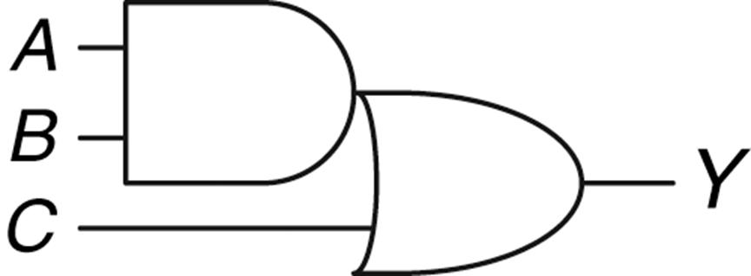

1.